Team Budget Calculation

Screenshots :

1)App overview

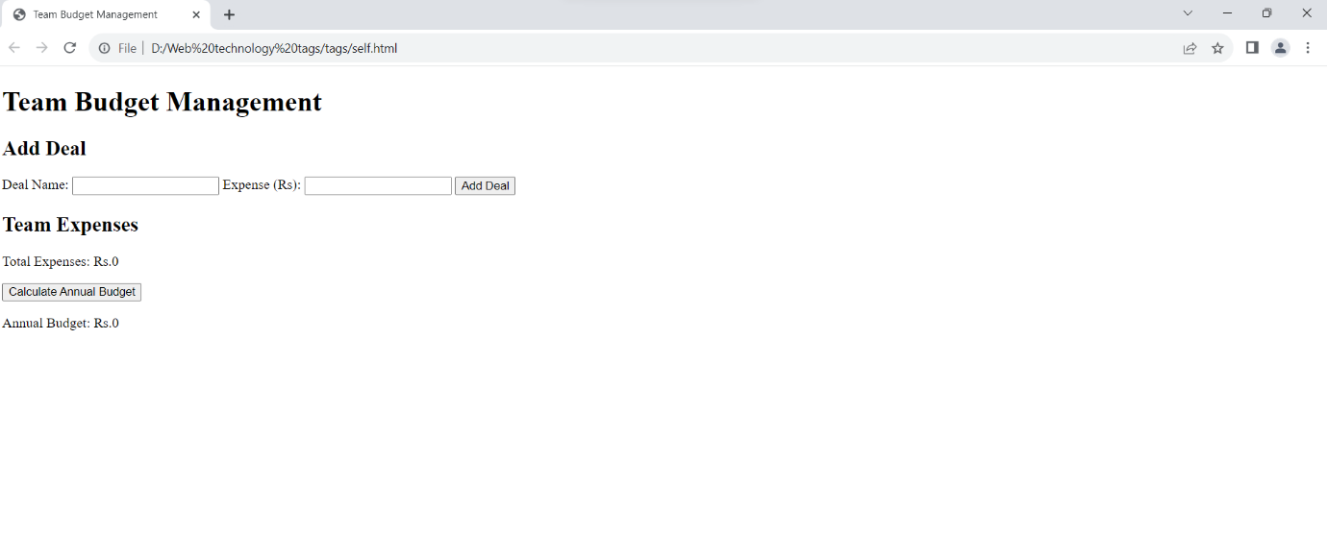

2)Enter details of budget as name and expense

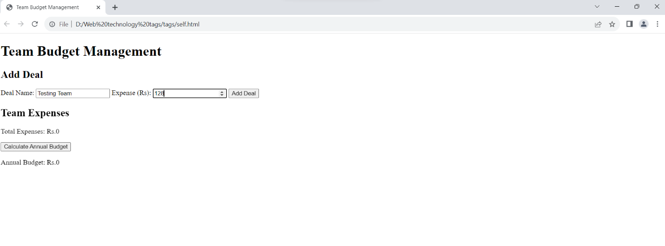

3)Calcualting annual budget and getting output

